**Department of Computer Science**

**BSCS(Hons)**

**PROJECT Report**

**ON**

**TIC TAC TOE GAME**

Submitted to

**Ma’am Asma Kanwal**

Department of Computer Science

GC University, Lahore

Submitted by

Haider Ali 0270-BSCS-18 haiderali98.ha61@@gmail.com

Section

E2



# **Abstract:**

The game that I am designing is actually a two-player game. Basically, the game has 9 boxes placed 3 in each line and wo win the game you have to fill the boxes that are in sequence with your sign, that they make a single line. The lines can be made in 3 ways, which are **Horizontal**, **Vertical**, and **Diagonal**. Both players get their turn to fill the box, the player to fill the boxes that make a line wins the game. It’s easier said than done. The box will have both Multiplayer and Single Player Option. Besides that, this project will have many more cool features at the back end like having a full fledge database of each player and a chat-box. This project will be totally composed on Graphical User Interface (GUI).

# **Introduction:**

Tic Tac Toe, naught and crosses, or X and O is a paper-and-pencil game for two players, X and O, who alternate denoting the spaces in a 3×3 matrix. The player who prevails with regards to putting three of their imprints in a level, vertical, or corner to corner column is the winner. So as to dominate the match, a player must place three of their imprints in a level, vertical, or inclining line. The accompanying model match is dominated by the primary player, X:

**Game of Tic-tac-toe, won by X**

Players before long find that the best play from the two players prompts a draw. Thus, tic tac-toe is regularly played by small kids, who frequently have not yet found the ideal methodology.

**Rate structure for tic tac-toe.**

As a result of the effortlessness of tic tac-toe, it is regularly utilized as an instructive apparatus for showing the ideas of good sportsmanship and the part of man-made consciousness that manages the looking of game trees. It is direct to compose a PC program to play tic tac-toe impeccably or to specify the 765 basically various positions (the state space intricacy) or the 26,830 potential games up to revolutions and reflections (the game tree multifaceted nature) on this space.[1] If played ideally by the two players, the game consistently finishes in a draw, making tic tac-toe a pointless game.[2]

The game can be summed up to a m, n, k-game in which two players interchange setting stones of their own shading on a m × n board, with the objective of getting k of their own shading in succession. Tic tac-toe is the (3,3,3)- game.[3] Harari’s summed up tic tac-toe is a significantly more extensive speculation of Tic tac-toe. It can likewise be summed up as a ND game. Tic tac-toe is where n rises to 3 and d approaches 2.[4] It can be summed up much further by playing on a discretionary rate structure, where lines will be lines and cells are focuses. Tic tac-toe is the game given by the occurrence structure appeared to one side, comprising of nine focuses, three flat lines, three vertical lines, and two corners to corner lines, each line comprising of at any rate three focuses.

# **Objectives of the game:**

The game is developed for full-time entertainment and enthusiasms. It teaches the Gamer to be alert at every situation he/she faces, because if the Gamer is not fully alert and notice the saucer fire he/she must be hit by the saucer-bombs.

Though the proposed game is an action game, it doesn’t involve direct violence. No zombie killing,

animal killing, or human killing is performed in the game. So it can also be viewed as a non-violence game. Kids can also play this game, because the design of the game is very simple, controlling the game is very easy

 –

 pressing some neighboring keys of the keyboard

## **Programing Language:**

**C sharp** is used to write the whole code and in C sharp, **window form** is a Graphical user interface **(GUI)** class library that is included in the .Net framework. The primary aim is to provide a simpler framework to build PC and Desktop application. Window Forms applications can include various types of controls which are buttons, data grid view, labels, Text boxes, menu strip, etc.

I tried my best to make it work using the best of at artificial intelligence and hopefully it is better. Following is the list of things I tried to apply.

1. Created a Tic Tac Toe game in Visual Studio using C# programming language
2. Used Buttons, Timers and Labels to create this game
3. Used Functions, If Statements and Loops to make the game work
4. Used List<> in C# and Dynamically add and remove items from it
5. Created custom functions to suit the games purpose
6. Created an Artificial Intelligence Opponent to play with
7. Used the C# Random Class to select random buttons in the game
8. Kept score for both Player and AI

# **Main Form:**

The Main of the game shows us the types of the game we’d like to play. I used Label saying Single or Multiplayer and there are two buttons through which we can select the type of the game.

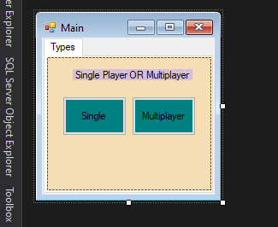

# **Single Player:**

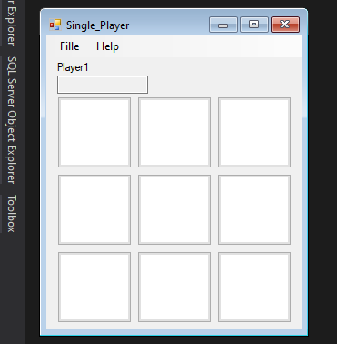

**Buttons:**

I used the buttons to represent each box of the game and applied functionalities on them. The AI will see if you taking your turns is making you win the game, and it will try to avoid that in the best way I knew I could.

**Timer:**

The computer will take a split second to take its turn after every time you chose a box and print your mark on it. The timer intervals are set on 500 for this game.

**Intelligence:**

The program is designed in a way that lets not the user to win easily unless he or she uses the trick against the AI. But this program tends to make mark on that crucial box which on otherwise would’ve been very easy for the user to win. I typed the hard code in this game as having no prior knowledge about AI and how it works. So, I can say it looks pretty amazing and all.

**First Priority:** If the game takes the both players, AI and user, to a situation in which if AI prints its mark at a particular box, it will win a game. Then AI will sure print its mark at that particular box. Thus, AI wins. This is the first priority of the AI, as it lets it win the game and as well as oppose the user.

**Second Priority:** If the game takes the both players, AI and user, to a situation in which if the user prints its mark at a particular box, he or she will win a game. Then AI will sure print its mark at that particular box. Thus, not letting the user to win the game so easily, unless he or she tricks the AI and wins the game based on the human intelligence. This is the Second priority of the AI, as it does not let the user to win the game.

**Third Priority:** If the game takes the both players, AI and user, to a situation in which neither the user nor the AI needs to prints its mark at a particular box. Then AI will select the random box from the boxes which are left. Though I tried to make it work like, in this condition AI should print at the particular box which takes it one step further towards winning the game. But, unfortunately that was quiet hard to do so, as I came to know the endless possibilities by doing this.

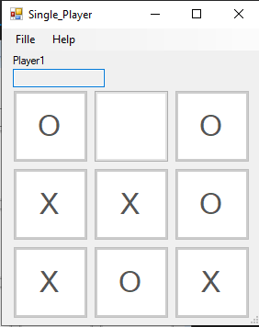

As you can see the sign “O” is not letting the Sign “X” wins. The Sign is being handled by the AI and the user controls the sign X.

# **Multiplayer:**

Pretty basic Stuff. Both controls are in the hand of the user and it depend totally in their intelligence in tacking the game.

# **Database:**

There is a database attached with this game, because what good would a game be if it has no record of its players. There are two players set at the back end of the game, by the name of admin and admin2 and same passwords respectively. So, if you enter yourself as an admin or admin2 in both the textboxes, this program will let you have access to the game. Otherwise Message box will appear saying that you did not put the valid username or id.

**Admin**

**Admin Login** **Game**

**Sign-up Page:**

If you’re new to this game, then you can sign up to our servers and can apply to play this entertaining short game, When you reach the Main form, it’ll have an option to register now, click on that and it’ll take you to where you’ll have to submit your name and password accordingly. After That your data is stored in our server, and you can have access to the game using the same information you put in.